EDCONNECT LEARNING CENTRE

## Project Report Template

## Introduction

EduConnect Learning Centre is a forward-thinking educational institution dedicated to providing high-quality learning experiences and innovative educational solutions. Established with a commitment to fostering knowledge and skills development, EduConnect Learning Centre offers a diverse range of programs and services designed to meet the unique needs of learners in today's dynamic educational landscape.

## Overview

Whether you're a student seeking academic support, a professional looking to enhance your skills, or an individual interested in lifelong learning, EduConnect Learning Centre aims to empower and inspire through its diverse curriculum, experienced educators, and cutting-edge resources. With a focus on adaptability and staying at the forefront of educational trends, EduConnect Learning Centre is committed to helping individuals achieve their learning goals and excel in their chosen fields.

## Purpose

* 1. EduConnect Learning Centre primarily exists to provide education and facilitate skill development. This can encompass a wide range of subjects and fields, catering to learners of various ages and backgrounds. It often serves as a resource for students seeking additional academic support, whether it's in the form of tutoring, test preparation, or enrichment programs.

## 2 Problem Definition &Design Thinking

## 2.1Empathy Map

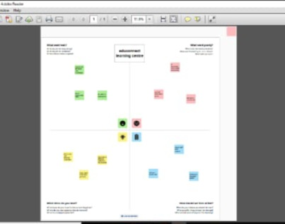

## 2.2 Ideation & Brainstorm Map

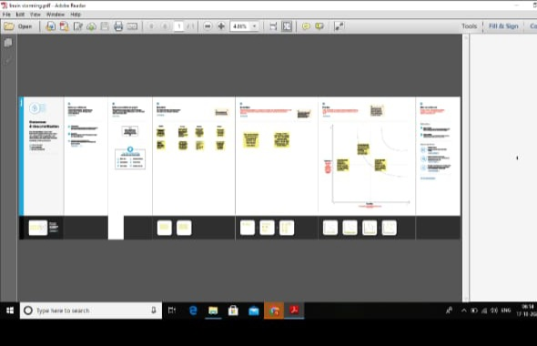

## 3 RESULT

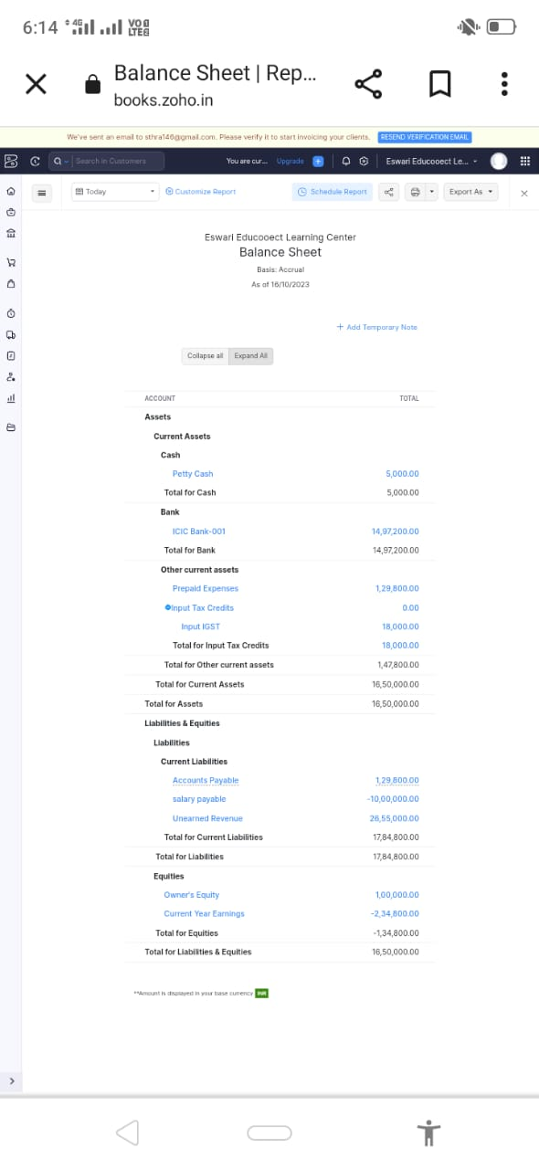

## 4.Advantage & Disadvantage

EduConnect Learning Centre can provide high-quality educational resources and instruction, which can lead to improved learning outcomes. Many learning centers offer personalized learning plans, catering to the unique needs and learning styles of individual students. It can serve as a valuable resource for students seeking extra help with their studies, including tutoring and exam preparation.

## Disvantage

Educational programs at learning centers can be expensive, making them inaccessible to some individuals. If EduConnect has a physical location, it may only serve those within a specific geographic area, limiting access for individuals in other regions. The quality of education and instruction can vary from one learning center to another, so it's essential to research and choose a reputable institution.

Mission Statement: "At EduConnect Learning Centre, our mission is to empower individuals of all ages with the knowledge, skills, and resources they need to thrive in the ever-evolving world of education. We are committed to providing a dynamic and inclusive learning environment where personalized, high-quality education is accessible to everyone. Through innovative teaching methods, technology, and a passionate team of educators, we aim to foster a love for learning and ensure that every student reaches their full potential."

Vision Statement: "Our vision at EduConnect Learning Centre is to become a global leader in educational excellence and innovation. We aspire to revolutionize the way people learn by creating a learning ecosystem that is adaptable, accessible, and enjoyable. We envision a future where education knows no boundaries, where anyone, regardless of age, background, or location, can access the knowledge they seek. We will continually invest in cutting-edge technologies, diverse teaching approaches, and collaborative partnerships to make this vision a reality, creating a world where education is the key to unlocking limitless opportunities and personal growth."."

## Conclusion

Edu Connect Learning Centre stands as a beacon of educational empowerment, driven by a clear and compelling mission and vision. Their commitment to fostering a love for learning, ensuring accessibility, and utilizing innovative teaching methods makes them a formidable force in the realm of education.